ER Activity 2

Exercise 1

A Computer Science department has two types of postgraduate students: students who are enrolled on a MSc course, and research students. The attributes of the MSc students include the student id, the name, the date of birth and the course they are enrolled in (Computer Science, Software Engineering etc.). The attributes of the research students include the student id, the name, the date of birth, the research programme (MPhil or PhD), and the name of the supervisor.

Generate an ER diagram from the above scenario.

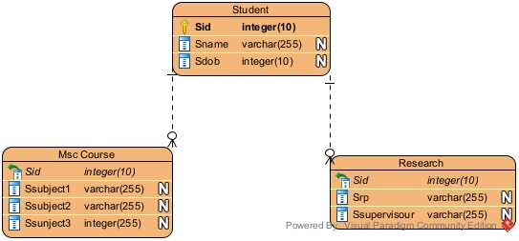

Exercise 2

For each of the following scenarios,

Generate, with justification, a corresponding E-R diagram to represent each case. Indicate clearly the attributes, the cardinality and the type of participation.

a) The Human Resource (HR) department of an organisation keeps a record of the

qualifications of its employees. Each employee is uniquely identified by his/her

employeeId. A qualification has qualificationType and date as attributes.

QualificationType and date are not sufficient to uniquely identify the qualification of

an employee.

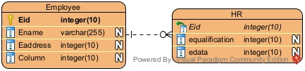

b) In a School of Computer Science teaching is based on units. Examples of unit of

teaching include Operating Systems, Relational Model and Computer Architecture. A

unit such as Operating Systems may be composed of smaller units (e.g Computer

Architecture and Data Structures) and may be part of many larger units, such as

Distributed Systems or Web Technologies. A unit is identified by its unit number

(unitNo) and has a title as attribute.

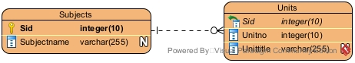

c) In a School of Computer Science an instructor may lecture on zero or many teaching

units. Each unit is taught by one or many instructors. An instructor is identified by

instructorId and has name as attribute. A teaching unit is identified by unitId with

unitTitle as attribute. There is also a need to record the time and place of each lecture

by the instructor of a unit.

